TEAM REDCURRENT

**Team members:**

* **baretata ( Златко Атанасов )**
* **eagancheva (Елена Ганчева)**
* **half.human (Радослав Ангелов)**
* **momo333 (Мария Косева)**



PROJECT: GAME RIBESTERRA

The game:

The game is console reproduction of popular MMORPG games like World of Warcraft and League of Legends, based on one fantasy persistent world of creatures (including the main player character), they can fight each other with different result according the start or current characteristics of the creatures in the battle.

It’s a fantasy game there the player attack other creature(enemy) and has to make as possible damage or to destroy the opponent in the fight (according to the characteristics of the character in the game) . All the characters has attack and defense points according to the race they belong to, also the characters have initial amount gold, which could be lost in battle or could be increased after fight. The difficulty for the main character in fight increases with opponents with higher level (with higher attack or/and defense points).

Competing in battlegrounds rewards the character with healthpoints and gold that can be used to buy armor, weapons, and other general items that can aid a player in many areas of the game.

The player can choose to use in the game two type of Spells – attackspell and healspell.

The player have option to use ItemShop:

* to buy set of items - weapons, clothes and armor
* to update weapon/item

ItemShop include implementation of structure with sets of items and weapons which the player can buy from the shop and methods for update of items.

The main command for the character are:

**Attack** – attack the enemy in fight, cause damage on the enemy

**Shop** – the player can buy items – weapons, armor and other defense items in the Item Store, choosing from different sets of equipment

All the commands and the characteristics of the character in fight could be seen listed on the console.

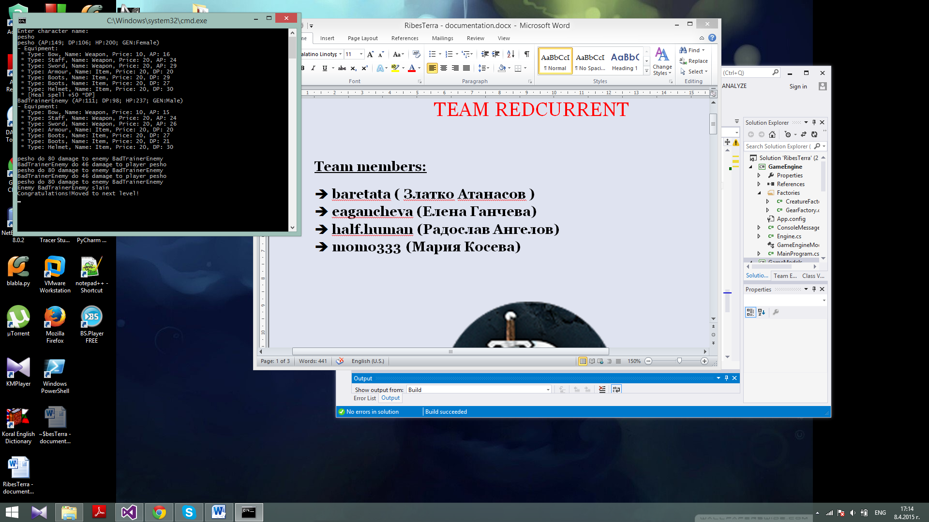

The hierarchy of the game include (shown down fig.1 class diagram with classes and interfaces).

Implemented:

* Design Pattern – Factory pattern for creating the creatures in the game and the item in the character equipment.
* Lambda Expressions and LINQ – in Game engine, execute logic for sorting the enemies, indexers
* Base constants in the game are in separated class ConsoleMessageConstants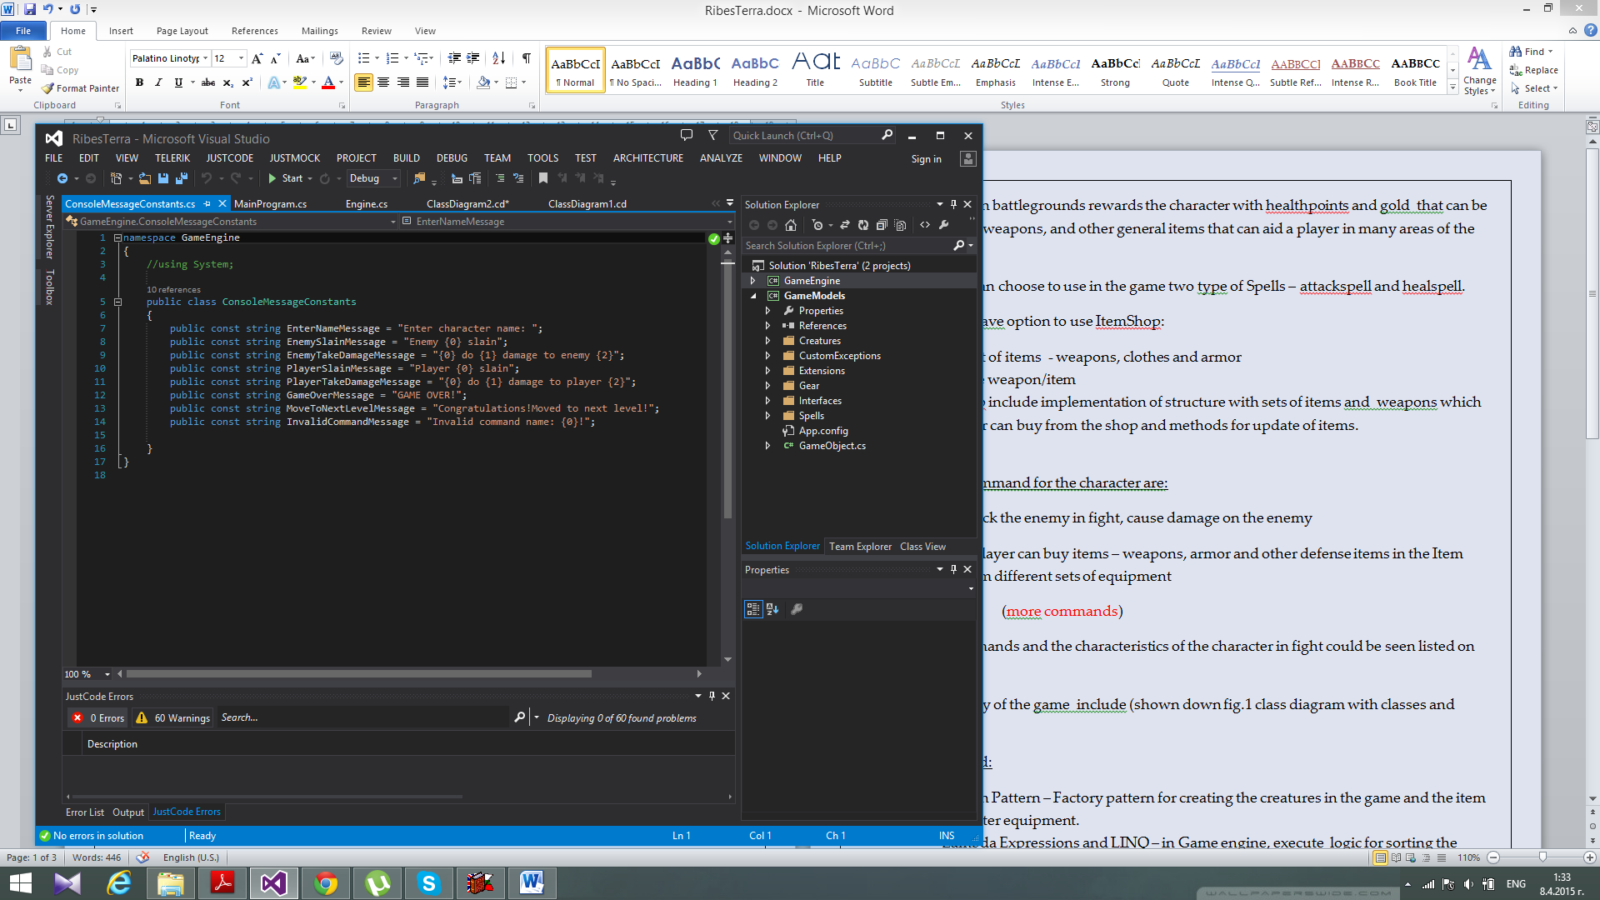
* The project is divided in two namespace according to the logic and the structure of the game

1. Game Engine
2. Game Models

* User Interface - the interaction with the player is executed from the console, by entering commands from the player
* Implemented interfaces IEnumerable, and overrided more than 3 methods ToString()
* Implemented event in the game engine
* The project is uploaded in Github – link https://github.com/baretata/CSharpOOP-TeamRedCurrantGame

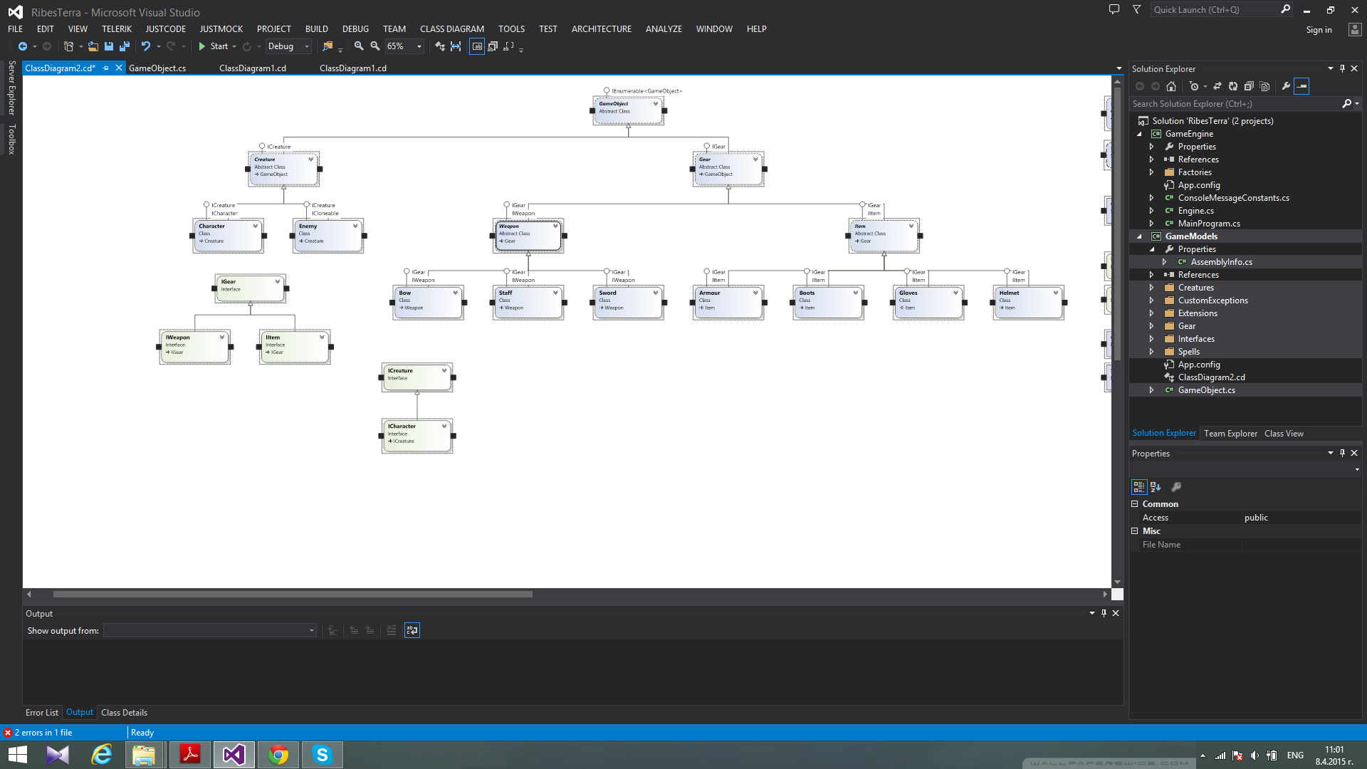

Fig.1 Class Diagram

 